### Quiz Question

Which of the following is not accurate about entropy?

1. The more knowledge one has, the less entropy
2. The less knowledge one has, the less entropy
3. The less knowledge one has, the more entropy

### Quiz Question

Which function will help us turn products into sums?

1. sin
2. cos
3. log
4. exp

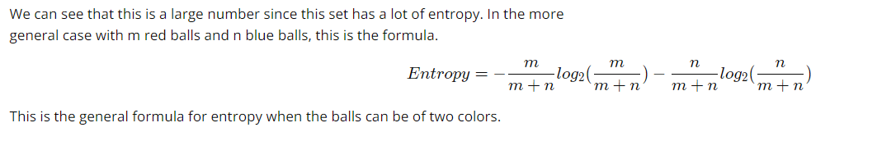

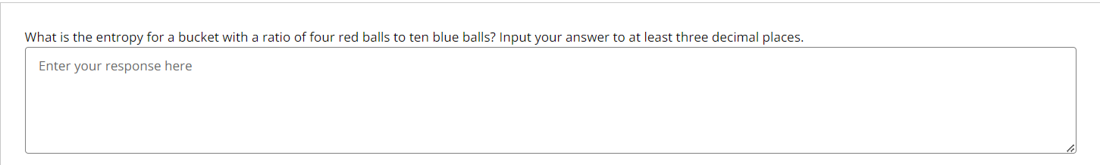

Answer: 0.863

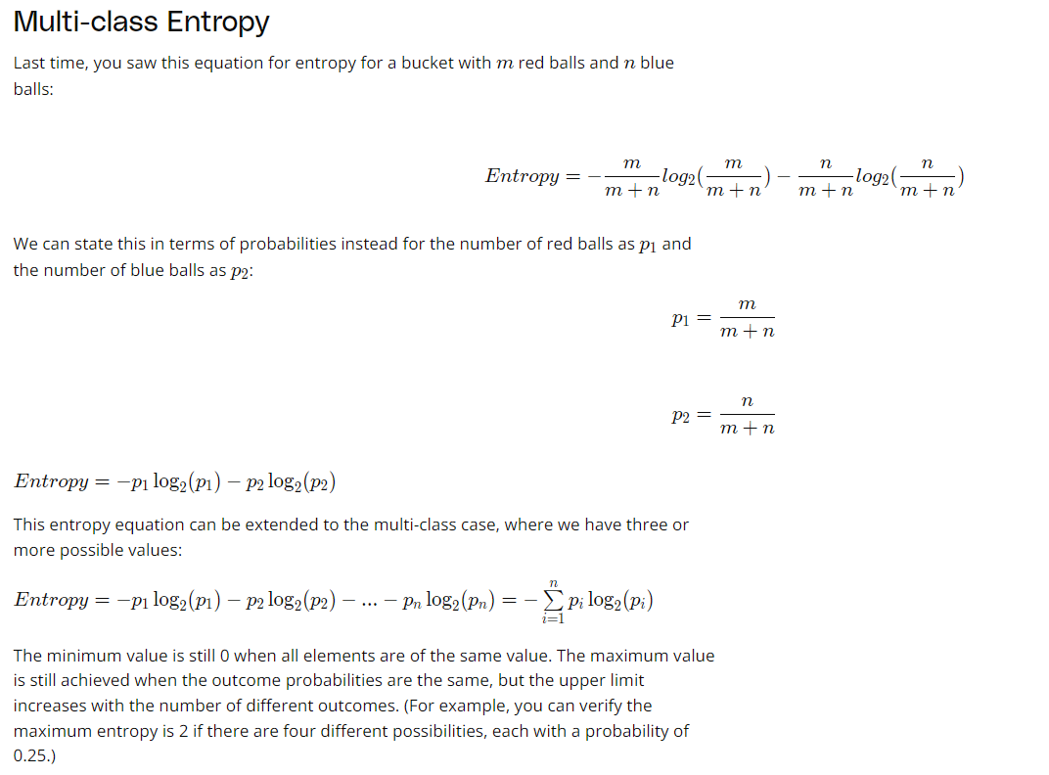

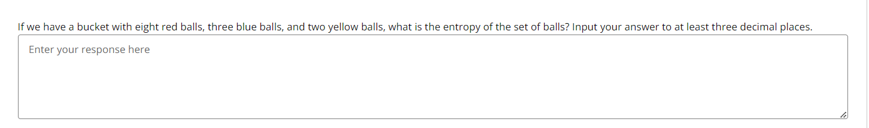

Answer: 1.3346